* 10-12 month release cycle
* Aspen-2011, Berlin-12, Calgary-13,Dublin-13,Eureka-14
* We can export & import groups & other config data using XML export & import
* Releases
  + ● ~10-12 month release cycle
  + ● Feature release, patch release, hotfix
  + ● New UI, new apps, new features
  + ● Always evolving
  + ● Releases:
    - ○ Aspen 2011
    - ○ Berlin2012
    - ○ Calgary 2013
    - ○ Dublin 2013
    - ○ Eureka 2014
    - ○ Fuji 2015
    - ○ Geneva 2015
    - ○ Helsinki 2016
    - ○ Istanbul 2017
    - ○ Jakarta 2017

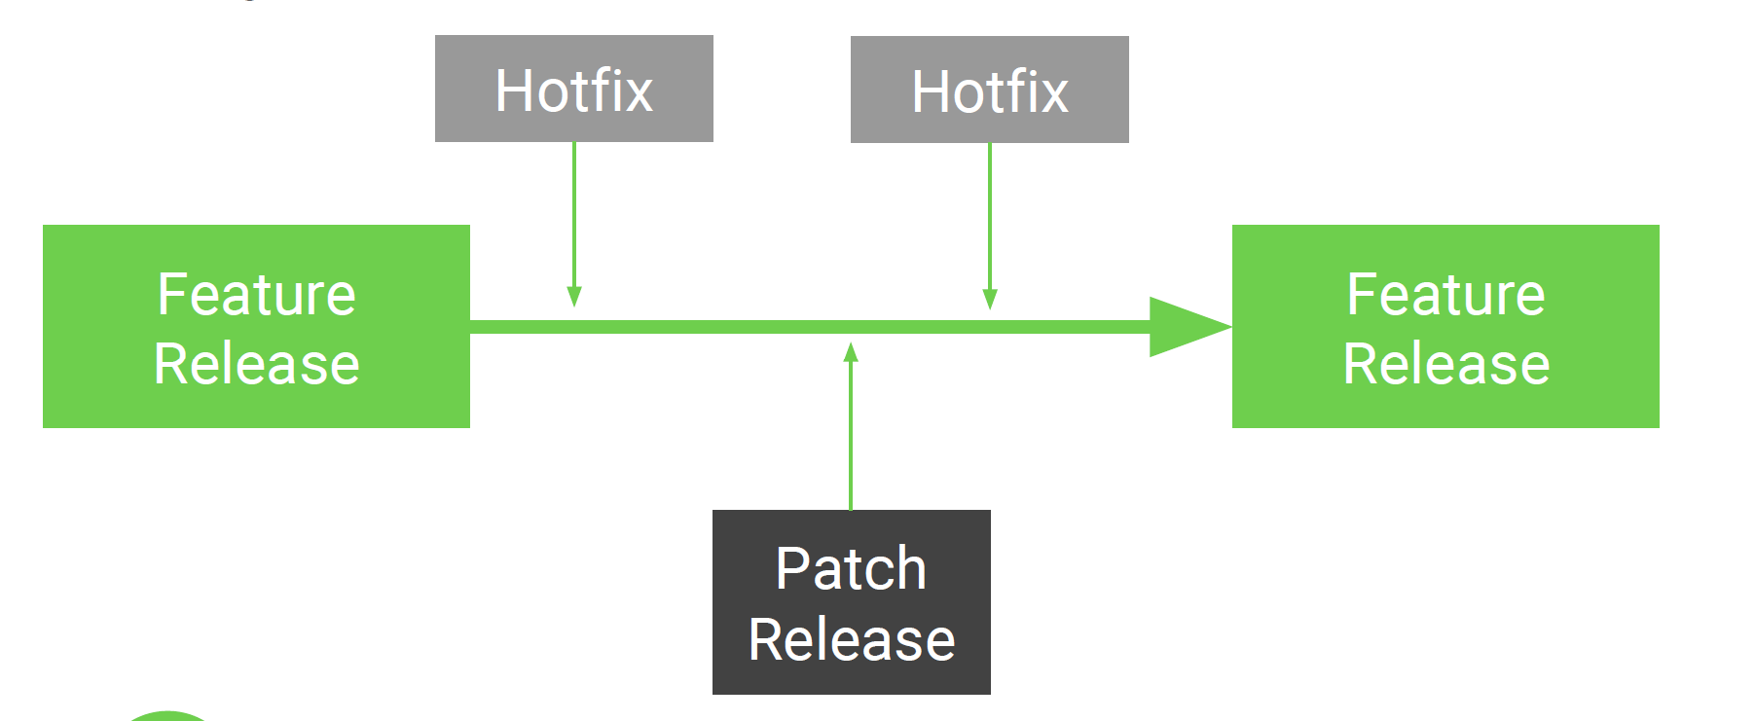

* NOTE: To check the release version of an instance, type **stats.do** followed by the enter key in the application navigator
* Environments
  + ● Clone environments
  + ● Push changes from 1 instance to another
  + ● Test should be as close to Production as possible
* Update Sets
  + ● Record most customizations & configurations
  + ● Used for moving changes from instances
  + ● XML snapshot of record
  + ● Versions & merging
  + Captured:
    - 1. customizations
    - 2. tables & fields
    - 3. reports
    - 4. workflows
    - 5. Forms
  + Not Captured:
    - 1. data, new records
    - 2. CIs
    - 3. schedules
    - 4. users
    - 5. Groups
  + The ServiceNow Stack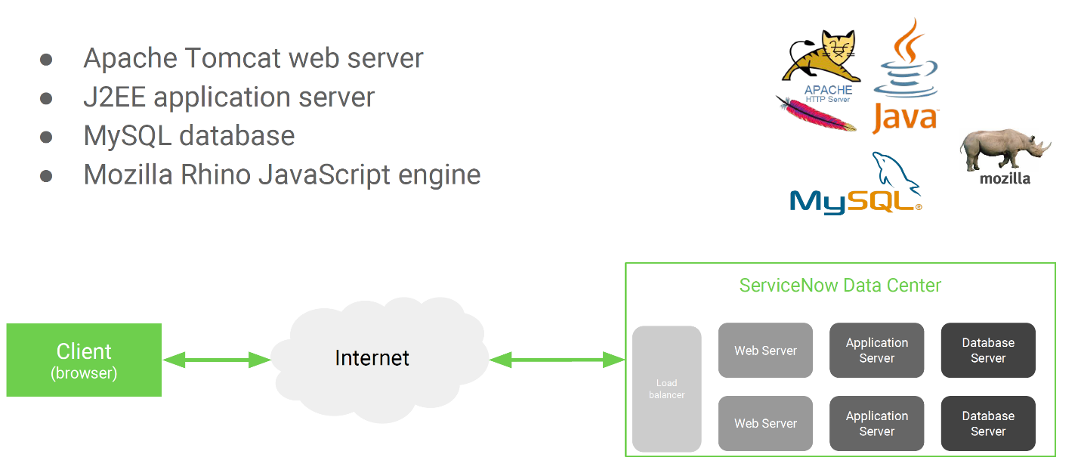
* Table Overview
  + - ● Over 2,000 tables in base instance
    - ● Each application has 1 or many tables
    - ● Each table has many fields
    - ● Extend other tables
    - ● Naming convention
    - ● Create/modify tables
  + Table Relationships
    - ● Example:
    - ○ Person table has firstname and lastname fields
    - ○ Student & faculty tables extend person table,
    - thus student & faculty tables inherit firstname and lastname fields
    - ● Dictionary overrides
    - ● Very common in CMDB
  + Example: CMDB Tree Structure
    - ● Hundreds of CMDB tables
    - ● Majority of tables extend cmdb_ci table
    - ● New CI classes = new extended table
    - 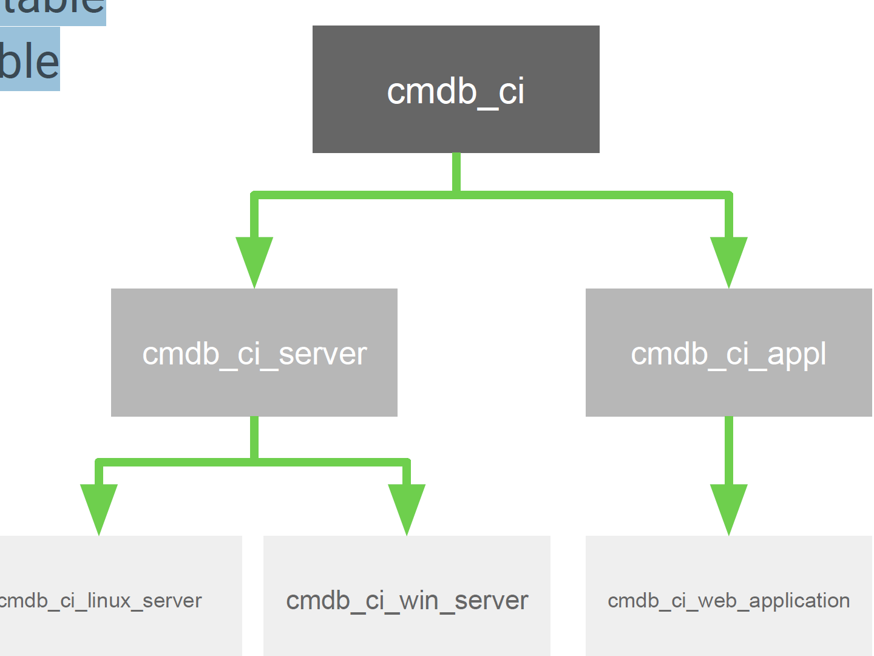
  + Major Tables
    - ● task
    - ● incident
    - ● problem
    - ● change_request
    - ● change_task
    - ● sys_user
    - ● sys_user_group
    - ● sys_user_role
    - ● cmn_location
    - ● core_company
    - ● kb_knowledge
    - ● kb_category
    - ● kb_knowledge_base
    - ● sc_request
    - ● sc_req_item
    - ● sc_task
    - ● sc_catalog
    - ● sc_cat_item
    - ● cmdb_ci
    - ● cmdb_ci_server
  + Tip: Tables & Columns Module
    - ● One stop shop for all tables and fields
    - ● Field attributes
    - ● Schema map
  + Schema Map
    - ● Visual schema map
    - ● Shows extended tables
    - ● Ability to focus on
    - different tables
  + Globally Unique Identifier (GUID)
    - ● A unique 32-character hexadecimal
    - string
    - ● Referred to by sys_id
    - ● Example: ef4225a40a0a0b5700d0b8a790747812
    - ● Used all throughout the system
    - ● Commonly paired with a table name
  + Databases, Tables, & Fields
    - ● A database contains many tables
    - ● A table contains many fields
    - ● Records are stored in tables
  + Records
    - ● Stored in database table
    - ● Single entity defined by a table’s fields
    - ● Each record has a unique key, the sys_id
  + ServiceNow Field Types
    - ● string
    - ● date
    - ● time
    - ● choice
    - ● true/false
    - ● list
    - ● HTML
    - ● script
    - ● reference

| **Field Type** | **Description** |
| --- | --- |
| Audio | Field for uploading and embedding .mp3 or .ogg audio files. |
| Choice | List of configurable choices. |
| Collection | Dictionary entries with the Collection type represent the table rather than a field on the table. Changes such as attributes or the Read only check box applied to this entry are applied to the table rather than a specific field. This entry is automatically created when a table is created. There should not be more than one entry for a table of this type. |
| Color | String field that accepts CSS color declarations (including hex or RGB notation) and displays a preview. To learn more, see <https://developer.mozilla.org/en-US/docs/Web/CSS/color_value>. |
| Condition String | Text field that accepts a plain JavaScript condition statement that is validated automatically for correctness before an update. |
| Conditions | Field that adds the condition builder to a form. You must specify a dependent field that references the table name. |
| Currency | Decimal field with four digits after the decimal point. When displayed on a form, a currency field also includes an additional choice list for selecting the currency type. If there is no default value for the field, empty currency fields use the reference currency. Adding a value causes the field to use the session currency of the active user. See [Change default currency decimal places](https://docs.servicenow.com/bundle/vancouver-platform-administration/page/administer/currency/task/change-currency-fraction-digits.html) for how to use two fraction digits.  **Note:** Once you assign this type to a field, you cannot change it to an **FX Currency** type. |
| Data Structure | Field that allows the selection of one of the following data structures and entry of values to organize particular information in the record.   * String * Boolean * Integer * Decimal * Object * Array |
| Date | Day, which can be selected with a calendar widget. |
| Date/Time | Day and time of day, which can be selected with a calendar widget. |
| Decimal | Number with up to two digits after the decimal points (for example, 12.34). |
| Document ID | Reference to any record on any table. |
| Domain ID | System field that contains a reference to the domain. |
| Due Date | String input field that stores a date-time. |
| Duration | Length of time. A time stamp stored in the database as date time. |
| Encrypted Text | Field that is encrypted for security. Depending on the user's encryption module access, the field may be hidden, the value may be hidden, or the field and value may display. |
| Field Name | Reference field for a field name in the table selected in a **Table Name** field type. Make this field dependent on the **Table Name** field. |
| File Attachment | Field for holding a file. A field holds one file. All file types are supported. |
| Floating Point Number | Number with up to seven digits after the decimal point. |
| FX Currency | Also known in internal code as Currency2 fields, this field type is an alternative to the standard (default) currency fields found in most Now Platform® applications. This type of currency field is highly configurable, supports custom rate tables, report aggregations, and provides for improved visibility into conversion calculations. To learn more about the FX Currency field type, see [Setting up and using FX Currency fields](https://docs.servicenow.com/bundle/vancouver-platform-administration/page/administer/currency/concept/fx-currency.html).  **Note:** Once you assign this type to a field, you cannot change it to an **Currency** type. |
| Geo Point | Field for holding longitude and latitude coordinates. |
| HTML | String field with a built-in HTML editor. |
| Icon | String field that provides the user access to an icon picker in a form. By default, the favorites icon set is used. |
| Image | Field for uploading and embedding images. |
| Integer | Number with zero decimal points.  **Note:** To search for an integer, input = followed by the integer in the search bar. For example, if you want to search for an Order of 100, input =100. |
| IP address | Variable character field that stores IPv4 and IPv6 addresses. See [IP address field type](https://docs.servicenow.com/bundle/vancouver-platform-administration/page/administer/reference-pages/reference/r-IPAddressFieldType.html) for more information. |
| Journal | Field that accepts text entries and displays previous entries with a user name and time stamp. |
| Journal Input | Field that accepts text entries but does not display previous entries. |
| Journal List | Field that displays the contents of journal fields. You must specify the journal fields as the dependent fields. If a journal list field depends on more than one journal field, the entries are displayed chronologically. |
| List | Reference field that accepts multiple references rather than just one. |
| Long | Integer field that can contain a longer number than the integer field. |
| Name-Value Pairs | Field that maps text values. Each mapping is one-to-one, however a single Name-Value Pairs field can contain multiple mappings. Each mapping must use a unique name, and the name cannot be empty.  For example, you can use a Name-Value Pairs field to hold header information for a web service request. In this example, the name of each mapping is the header such as Content-Type and the value is the header value, such as Application/json.  For information on scripting Name-Value Pairs fields, see [Name-value pairs field type](https://docs.servicenow.com/bundle/vancouver-platform-administration/page/administer/field-administration/reference/name-value-pair-scripting.html). |
| Password (1 Way Encrypted) | Text field that stores passwords with one-way encryption. One-way encryption stores the password as a secure hash value that cannot be decrypted. |
| Password (2 Way Encrypted) | Text field that stores passwords with two-way encryption. Two-way encryption stores the password as a secure encrypted value that can be decrypted programmatically within the instance. You can use Password 2 encryption with form variables. To encrypt text fields on forms, use [Password2 encryption with KMF](https://docs.servicenow.com/csh?topicname=password-2way-encrypted-fields&version=vancouver&pubname=vancouver-platform-security). The length for password2 field values must be at least 255 characters. |
| Percent Complete | Decimal field that renders a percent complete bar in lists. You can convert any existing decimal field to a percent complete field. |
| Phone Number (E164) | String field that provides E164-compliant formatting and validation for telephone numbers. |
| Price | A currency field that enables control over conversions and display. See [Price fields](https://docs.servicenow.com/bundle/vancouver-platform-administration/page/administer/currency/concept/price-fields.html) for more information. |
| Reference | Query that displays records from another table. |
| Script | Text field that accepts JavaScript code input and provides controls, such as syntax checking and formatting. It also provides a list of fields and server APIs. You must specify a dependent field that references the table name for the list of fields. |
| Script (Plain) | Text field that accepts JavaScript code input and provides controls, such as syntax checking and formatting. |
| String | For 255 characters or less, the string field is a single-line text field. Anything 256 characters or over appears as a multi-line text box.  **Note:** The database may translate the value that you provide in the **Max length** field to the closest matching database field type. For example, a max string length of 80 maps to the nearest database field type of VARCHAR(100).  For Oracle instances, users are not able to increase the max length of a string field to a value greater than 4000 through the application UI. Changes greater than 4000 require the CLOB data type in Oracle. If you require a field to be larger than 4000 characters, log an incident to request the change. |
| String (Full UTF-8) | String field that contains UTF-8 character encoding. This field type is restricted to the same maximum length that can be defined within the application UI as the String data type. Emojis are supported in the String (Full UTF-8) field type. |
| Suggestion | String field that provides suggested values but accepts free-form text. Available when you add a field by configuring a form or list. Otherwise, you must modify the dictionary entry of an existing string or journal field. |
| Sys ID | Field that contains a unique numerical identifier for each record. For more information about adding a Sys ID, see the following links:   * [Add a Sys ID to a form](https://docs.servicenow.com/csh?topicname=add-sysid-field-to-form&version=vancouver&pubname=vancouver-platform-user-interface). * [Add a Sys ID to a list](https://docs.servicenow.com/csh?topicname=add-sysid-field-to-list&version=vancouver&pubname=vancouver-platform-user-interface).   **Danger:** Modifying or deleting a Sys ID results in bad or lost data. |
| Table Name | String field that lets you select a table. If you use the **Field Name** field type, add this field type and make the **Field Name** field dependent on the **Table Name** field. |
| Time | Specific time. Stored in the database as a date/time field. Only the time part of this field is used.  **Note:** This field always stores the date as 1970-01-01, which does not fall within the dates for Daylight Savings Time (DST). As a result, the time is not automatically adjusted for DST. If a custom feature uses time as a start time, it is the responsibility of the feature to adjust for DST, if necessary. |
| Translated HTML | HTML field that displays different translations that are based on the user's language. |
| Translated Text | Text field that displays different translations that are based on the user's language. |
| True/False | Boolean field that appears as a one-digit integer, typically 1 (true) or 0 (false). |
| URL | String field that is a clickable URL field when locked.  **Note:** In the mobile UI, this field appears as a multi-line text field. The field saves as a single line, with the line breaks removed. |
| Video | Field for uploading and embedding video. |
| Wiki | String field with a built-in Wiki text editor that accepts a simplified version of standard Wiki text formatting. |
| Workflow | Choice list field that displays a stage in a workflow. |

* + Reference Fields
    - Reference fields store a reference to a specific row in another table, similar to foreign keys in SQL.
    - ● References are everywhere
    - ● sys_id is stored in reference field
    - ● Must match exact record
    - ● Reference qualifiers
      * User reference qualifies
      * Reference qual conition
      * Reference key
      * Reference float
  + Scripting Introduction
    - ● Scripting in ServiceNow is extremely powerful
    - ● Existing APIs - Don’t reinvent the wheel
    - ○ Glide classes
    - ● Very flexible - Little you cannot customize
    - The ServiceNow Glide classes expose JavaScript APIs that enable you to conveniently work with tables using scripts. Using the Glide APIs, you can perform database operations without writing SQL queries, display UI pages, and define UI actions.
    - When Is Scripting Necessary?
      * 80/20 rule
      * ● Customizing without scripting
        + ○ UI policies
        + ○ Workflows (without scripts)
        + ○ New tables & fields
      * ● When scripting is necessary:
        + ○ Integrations
        + ○ Complex business rules
        + ○ Client scripts
        + ○ UI actions
        + ○ Complex transform maps
        + ○ Service Portal
        + ○ Custom apps
    - Client Side Versus Server Side Scripting
      * Client
        + ● Where: User's browser
        + ● What: Makes request
        + ● Access to:
        + ○ Current form, fields, & values
        + ○ UI elements (DOM)
        + ○ Client-side APIs
      * Server
        + ● Where: ServiceNow data centers
        + ● What: Returns response
        + ● Access to:
        + ○ Database
        + ○ Server-side APIs
        + ○ Script includes
    - JavaScript
      * + ● Client-side
        + ○ Supported in every modern browser
        + ● Server-side
        + ○ Mozilla Rhino
        + ● One of the most popular programming languages
        + ● One of the most misunderstood languages
        + JavaScript is a high-level, dynamic, untyped, and interpreted run-time language… JavaScript is prototype-based with first-class functions, making it a multi-paradigm language, supporting object-oriented, imperative, and functional programming styles.
      * Scripting Environment
        + ● ServiceNow stack
        + ● JavaScript
        + ○ Rhino - ECMAScript 5
        + ● ServiceNow APIs
        + ● 3rd-party libraries
        + ○ Angular
        + ○ jQuery
        + ○ Other libraries…
      * Background Scripts
        + ● Great place to experiment
        + ● Server-side script
        + ● Access to ServiceNow APIs
        + Caution: Background scripts should be used with caution due to performance impacts and possible data loss
  + ServiceNow Studio
    - ● Available starting in Geneva
    - ● Integrated Development
    - Environment (IDE)
    - ● One stop shop for all configuration records
    - NOTE: Studio is only available for scoped apps (Custom apps) not for Global Apps
  + Important Concepts
    - ● Variable naming conventions
    - ○ ServiceNow: Underscores
    - ■ Example: hello_world
    - ○ Vanilla JavaScript: Camel case
    - ■ Example: helloWorld
    - ● The sys_id
    - ○ 32-character GUID
    - ○ Every record in the system has one
    - ■ Tables, fields, etc.
    - ● Field display value versus field value
    - ○ Most fields are actually objects, not strings
    - ○ Use getDisplayValue() for accessing a
    - field’s display value
  + Additional Resources
    - ● JavaScript resources
    - ○ codecademy
    - ○ codeschool
    - ○ JSBin / JSFiddle
    - ○ JavaScript: The Good Parts by Douglas Crockford
    - ○ Eloquent JavaScript by Marijn Haverbeke
    - ● ServiceNow resources
    - ○ Youtube channel
    - ○ API docs
    - ○ JavaScript primer
    - ○ 3rd-party websites
  + Scripting
    - 30 Scripting locations
    - Business Rules
    - Script Includes
    - Client Scripts
    - UI Actions
    - UI Policies
    - Transform Maps
    - Scheduled Jobs
    - Workflows
    - Web Services
    - Service Portal Widgets
    - UI Pages & UI Macros
    - And more
  + Client Side:
    - Client Scripts
    - UI Actions
    - UI Policies
    - UI Page

G_form

G_user

* + Server side Scripting
    - Data Policies
    - Business Rules
    - Script Includes
    - UI Actions
    - Transform Maps
    - Scheduled Jobs
    - Workflows
    - Web Services
    - Service Portal Widgets
    - UI Pages & UI Macros
    - Events
    - Notifications
    - Schedules.

APIs

gliderecord

GlideDatetime

Glidesystem

* + Business Rules
    - A business rule is a server-side script that runs when a record is displayed, inserted, updated, or deleted, or when a table is queried.
    - ● Server-side
    - ● Most common scripting location
    - ○ JavaScript that runs on server
    - ● Triggered by database operations
    - ● ~2,400 out-of-box business rules
    - ● Access to:
    - ○ Current object (current)
    - ○ Previous object (previous)
    - ○ Scratchpad (g_scratchpad)
    - 1. User sends request to server for specific incident (query)
    - 2. Application server requests record from database server
    - 3. Database server responds to application server with record
    - 4. Application server checks for display business rules, then sends the response back to the user
    - 5. User modifies incident record and sends update request
    - 6. Application server receives update, checks for before business rules, then sends to database server
    - 7. Database server updates record
    - 8. Application server checks for after business rules
  + Client Scripts
    - Client scripts run on the client (web browser). You can use client scripts to define custom behaviors that run when events occur such as when a form is loaded or submitted, or a cell changes value.
    - ● JavaScript on client-side
    - ● Form views
    - ● Triggered by
    - ○ Field changes
    - ○ Page loads
    - ○ Form submissions
    - ○ Cell edits
    - ● Shipped to the browser
  + UI Actions
    - ● Server-side or client-side
    - ● UI actions can be
    - ○ Buttons
    - ○ Menu items
    - ○ Links
    - ● Typically configured for form views
    - Client (check box)
    - Table
    - ● Show on insert/update
    - ● Client
    - ● Type of UI action
    - ● Condition
    - ● Script
  + Server-Side UI Actions
    - ● Access to:
    - ○ current object
    - ○ GlideRecord API
    - ○ GlideSystem API
    - ● Default behavior
    - ● Runs server-side if Client checkbox is not checked
    - ● Better performance
  + Client-Side UI Actions
    - ● Check the Client checkbox
    - ● Provide the name of the Onclick method
    - ● Use action.setRedirectURL() to redirect user to another page
    - ● To call another UI action on the current form,use one of the following:
    - ○ gsftSubmit(gel(<ui_action_name>))
    - ○ gsftSubmit(null, g_form.getFormElement(), <ui_action_name>)
  + Server-Side & Client-Side UI Actions
    - ● Server-side & client-side functions
    - ● Must call the UI Action again using
    - ○ gsftSubmit()
    - ● Verifies the client-side code is complete
    - ○ if(typeof window == ‘undefined’)
  + Use Cases: UI Actions
    - ● Trigger Salesforce integration, creating an associated Salesforce ticket
    - ● Reject an approval record
  + UI Policies
    - UI policies offer an alternative to client scripts for dynamically changing information on a form. Use UI policies to define custom process flows for tasks.
    - ● Client-side logic
    - ● Primarily used on forms
    - ● 99% no scripting is required
    - ● Used to set form fields to:
    - ○ Read-only
    - ○ Mandatory
    - ○ Show/hide
  + Form View: UI Policies
    - ● Table
    - ● Conditions
    - ● UI Policy Actions
    - ● Script
  + Use Cases: UI Policies
    - Set an incident’s Short description field to read-only if the incident state is Closed
    - Hide an incident’s Resolution notes field if the state is Open
  + Script Includes
    - Script includes are used to store JavaScript that runs on the server. Create script includes to store JavaScript functions and classes for use by server scripts. Each script include defines either an object class or a function. Script includes run only when called by a server script.
    - ● Server side JavaScript
    - ● Store JavaScript classes & functions/methods
    - ● Reusable code
    - ● Only runs when invoked
    - ● Unique since they can be called from anywhere
  + Form View: Script Includes
    - ● Name
    - ● Client callable
    - ● Script
  + Script Include Characteristics
    - ● 2 types
    - ○ Classless
    - ■ Script include name = function name
    - ■ Server-side only
    - ○ Class
    - ■ typically extend another class
    - ■ Can be invoked via server-side or client-side
    - ● Important attributes
    - ○ Script Include name
    - ○ type property
    - ○ prototype
  + Extending Script Includes
    - ● Any class may be extended
      * ● AbstractAjaxProcessor is a commonly extended class used for GlideAjax
    - ● <className>.prototype = Object.extendsObject(<extendingClassName>, { /* your script */ });
  + Use Cases: Script Includes
    - Create commonly used helper functions
    - Call a custom function via GlideAjax
  + Scheduled Jobs
    - Scheduled Jobs are automated pieces of work that can be performed at either a particular time, or on a recurring schedule.
    - ● Server-side JavaScript
    - ● Schedule when to run
    - ● Execute Now button for testing
    - Schedule
      * ○ Reports
      * ○ Scripts
      * ○ Charts
      * ○ Etc.
    - When to run (trigger)
      * ○ Daily/weekly/monthly
      * ○ Periodically
      * ○ Once
      * ○ On Demand
    - Note: You can trigger scheduled jobs in scripts by using the following method SncTriggerSynchronizer.executeNow()
  + Form View: Scheduled Jobs
    - ● Name
    - ● Active
    - ● Run
    - ● Day
    - ● Time
    - ● Run this script
    - ● Execute Now
  + Use Cases: Scheduled Jobs
    - ● Schedule a monthly report
    - ● Schedule a script to retire old records
  + Workflows
    - The Workflow Editor is an interface for creating and modifying workflows by arranging and connecting activities to drive processes.
    - ● Automated sequence of activities
    - ● Server-side JavaScript
    - ● Many locations to script in a workflow
    - ● Different scopes
    - ● Workflow contexts are created when workflow conditions evaluate to true
    - ● Versioning and checkouts
    - Scripting in Workflows
      * ● Only use scripts if OOB features aren’t
      * enough
      * ● Activities that support scripting
      * ○ Approval activities
      * ○ Run Script activity
      * ○ If, Switch, and Wait for condition activities
      * ○ Create task activity
      * ○ Notification activities
      * ○ Scriptable Order Guide activity
      * ○ REST Message, SOAP Message activities
      * ● Versioning and checkouts
      * Scope
        + ○ current record
        + ○ workflow.scratchpad object (sharing the variables & functions)
        + ○ Activity specific variables
        + ○ Local variables
      * Workflow Activity: If condition
        + The If activity checks a condition or script to determine if a Yes or No transition should be taken. If the workflow creator specifies both the Condition and the Advanced script, both must evaluate successfully for activity to take the Yes transition.
        + ● Must set answer to ‘yes’ or ‘no’
      * Workflow Activity: Wait for condition
        + The Wait for condition activity causes the workflow to wait at this activity until the current record matches the specified condition. The workflow evaluates the Wait for condition activity each time the current record is updated. Use this activity to pause a workflow indefinitely until a particular criteria is met by a record update...
        + ● Pauses workflow until script evaluates to true
        + ● Wait for condition is evaluated every time the record is updated
      * Workflow Activity: Approval - User condition
        + ● Creates a user approval
        + ● answer variable must be set
        + to comma-separated list or
        + array of user or group
        + sys_id’s
      * Use Cases: Workflow scripts
        + ● Dynamically assign approvals to a specific group of users
        + ● Trigger a web service call via a workflow activity
    - Rough Guide To Where To Customize

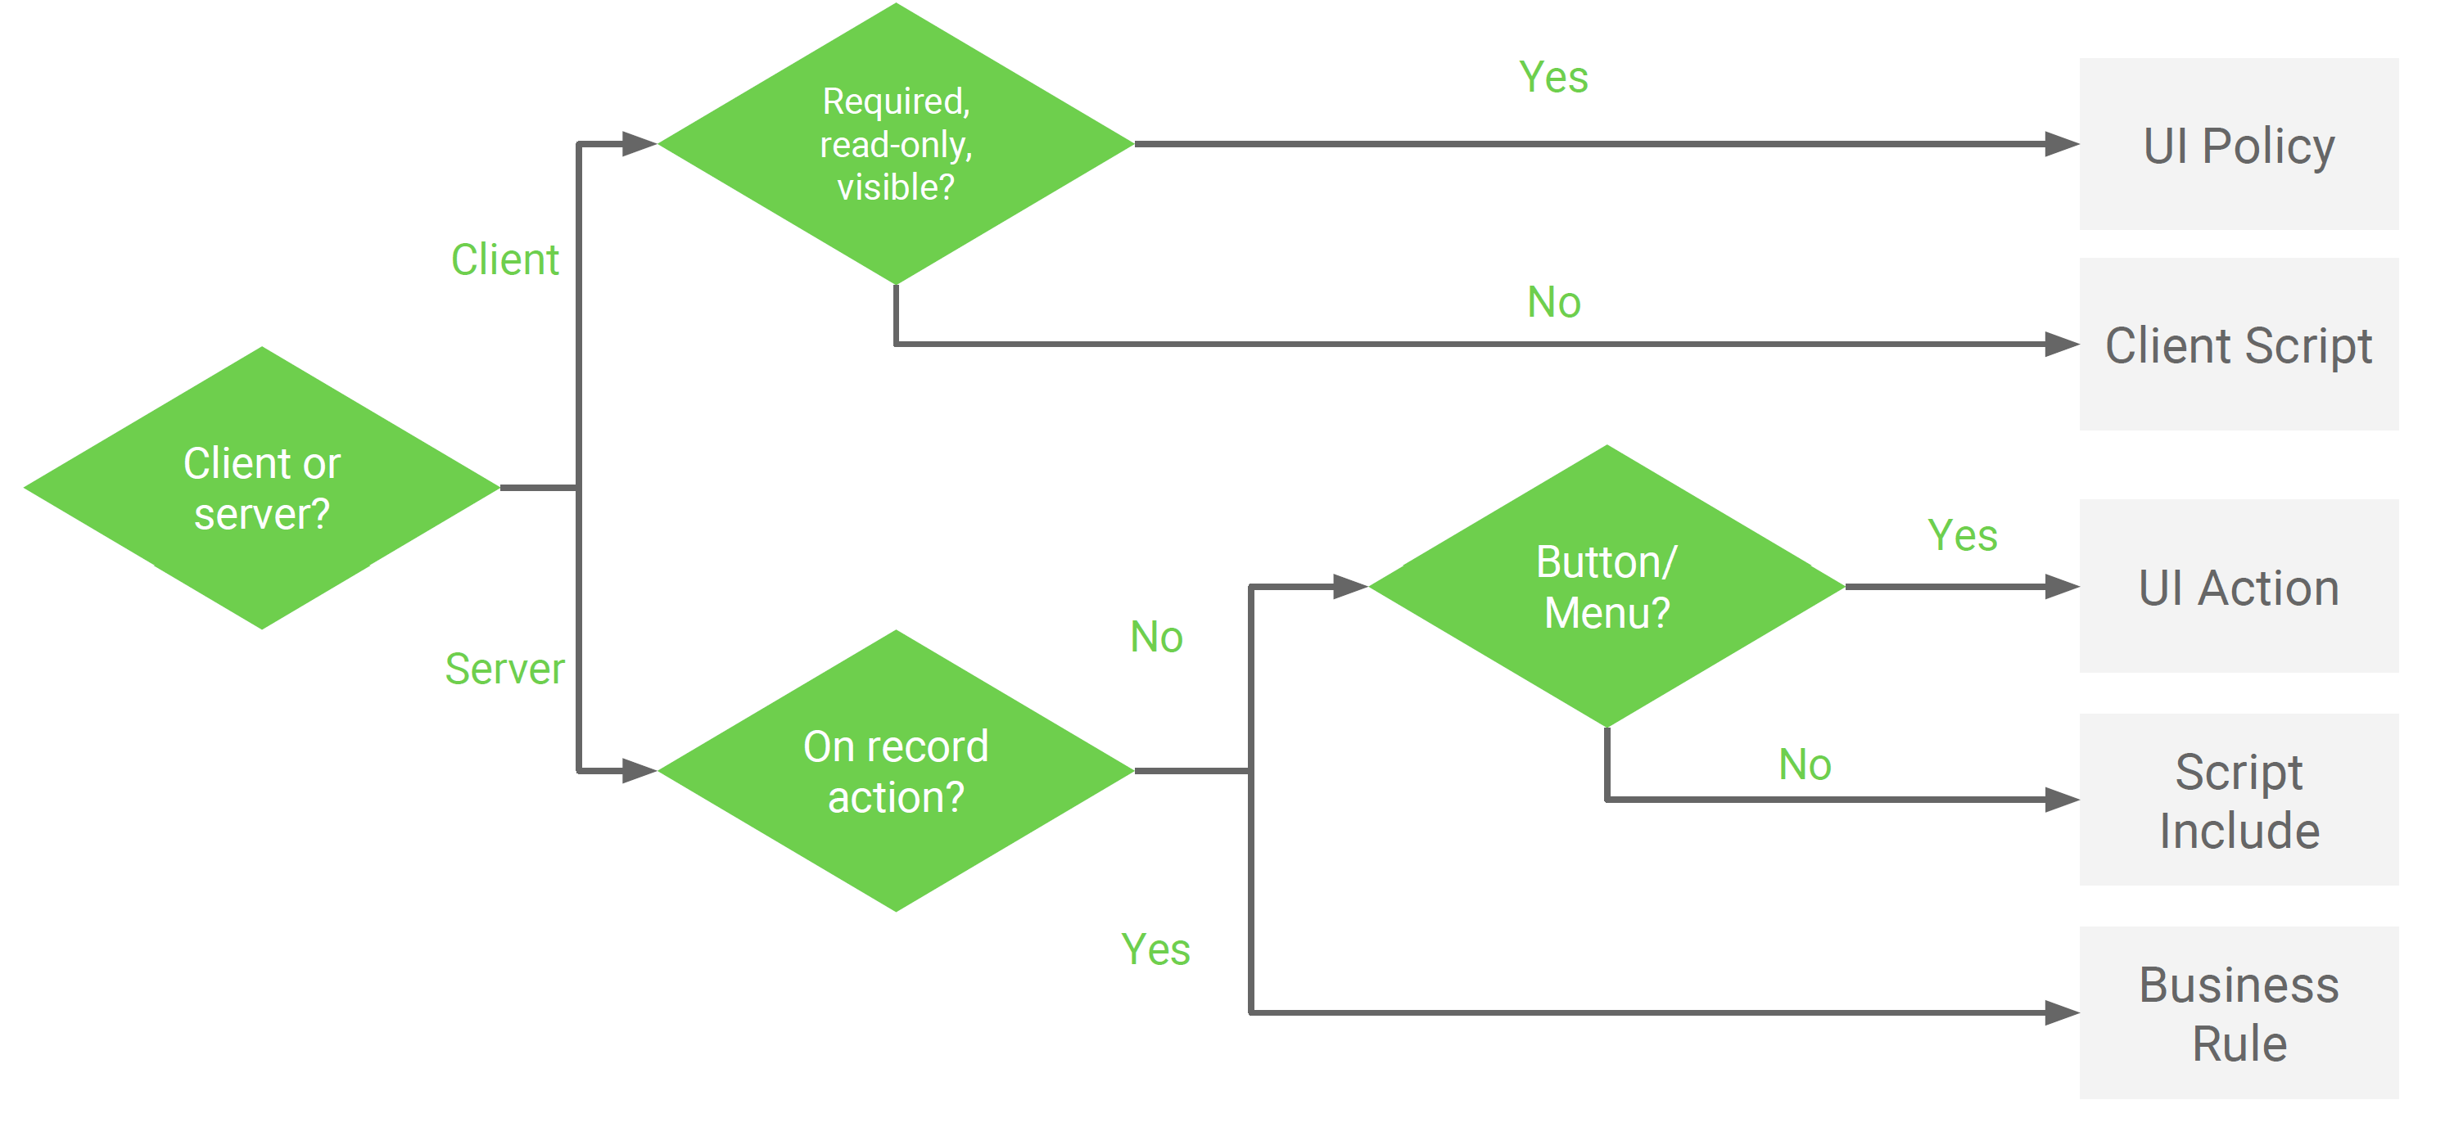

* APIs
* ● Application Programming Interface
  + ○ An API provides building blocks to help the developer
  + ○ Can define how to interact with a service or system
  + ○ Common tasks
  + ● ServiceNow APIs
    - ○ GlideRecord
    - ○ GlideSystem
    - ○ GlideUser
    - ○ GlideForm
    - ○ GlideAjax
    - ○ GlideDateTime
    - ○ Many more
* Where Can I Use This?
* 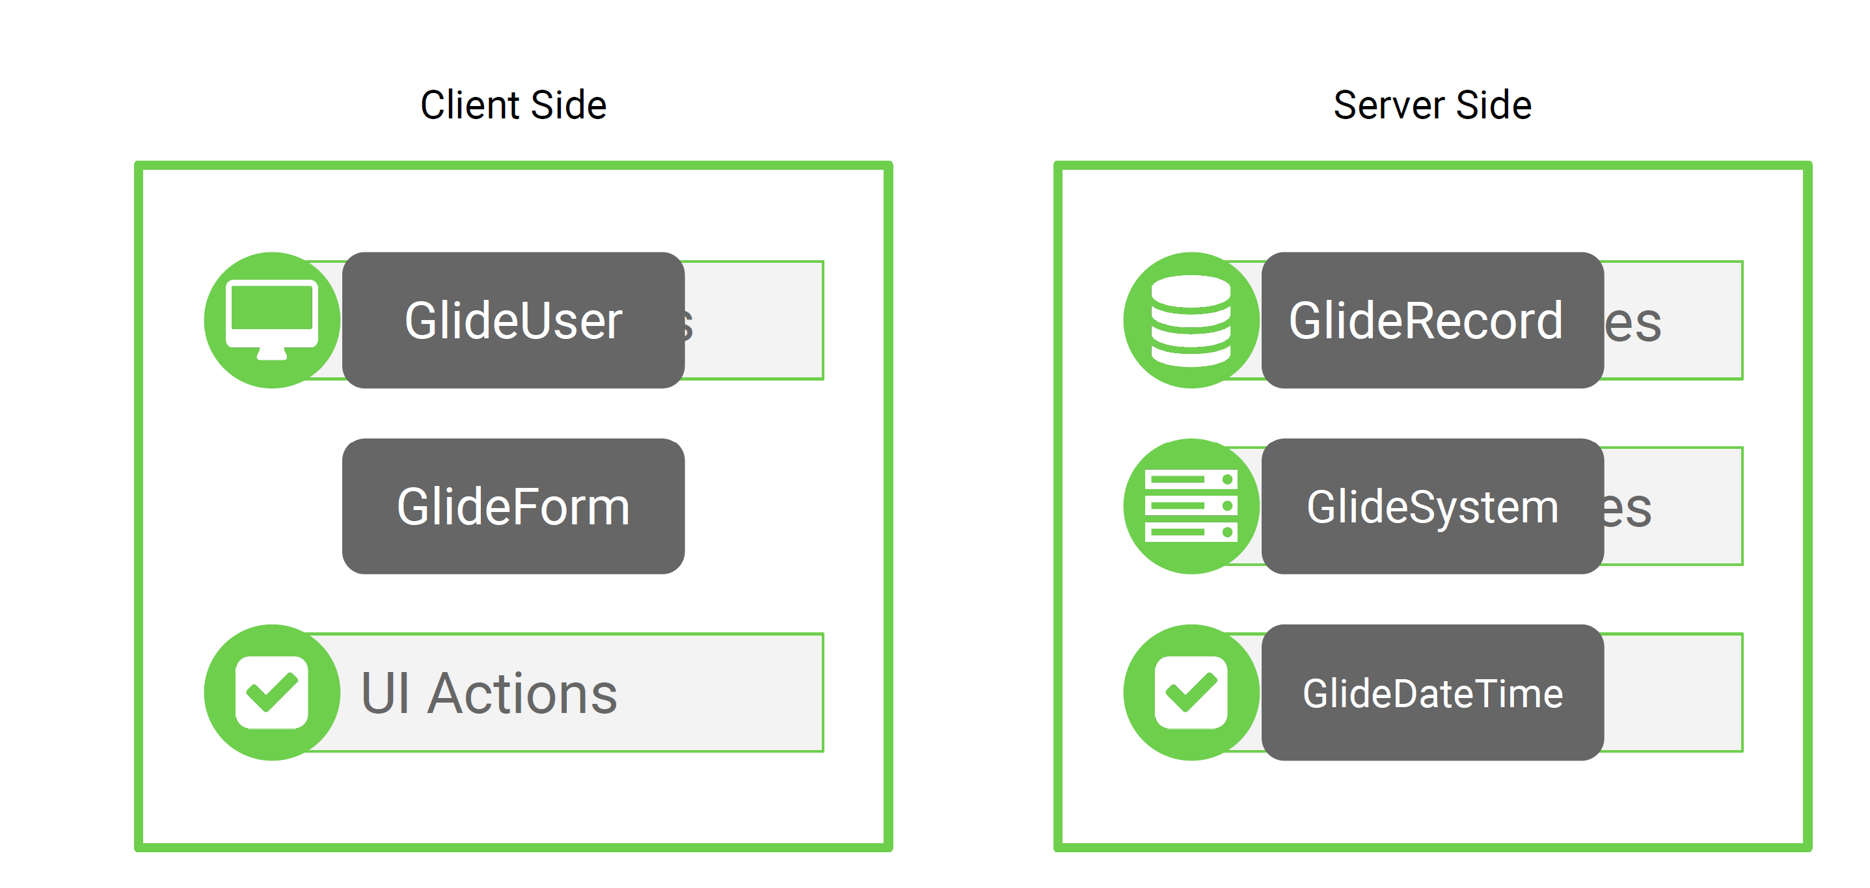
* 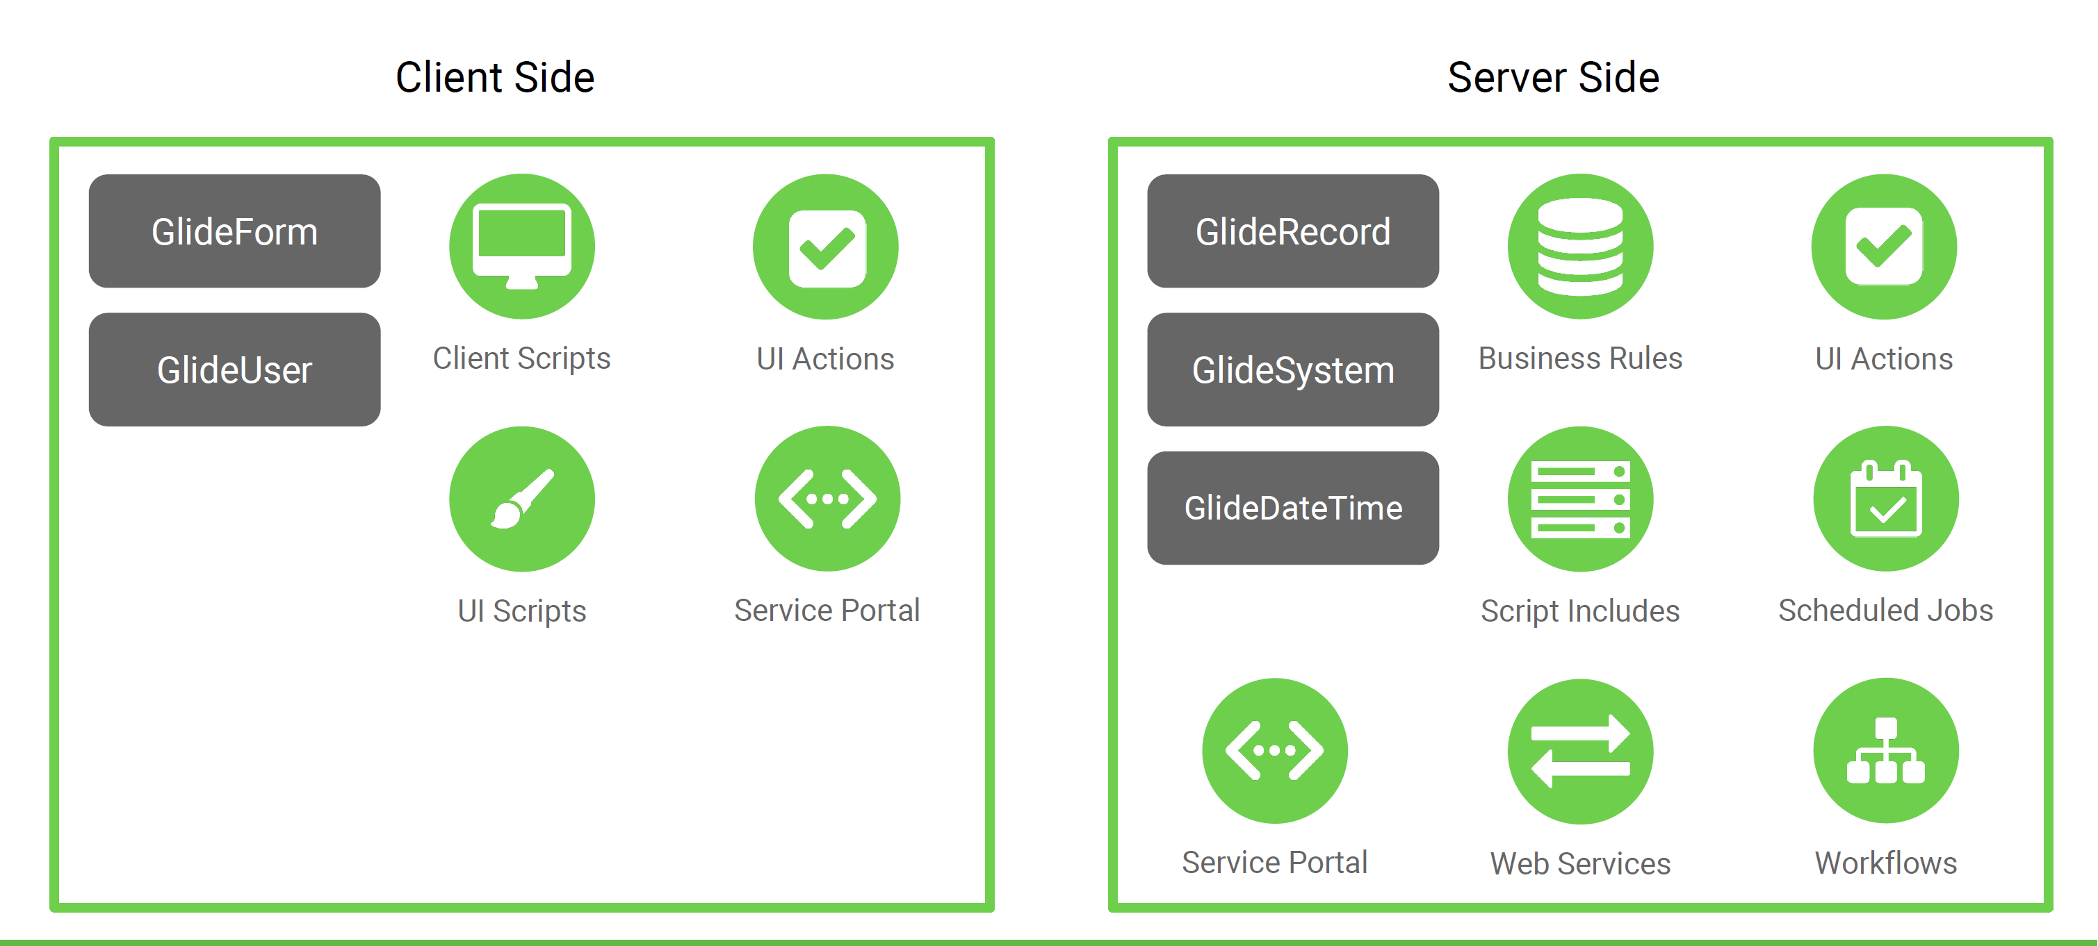
* GlideRecord Introduction
  + ● Most common API
  + ● Server side
  + ● Used for database operations (CRUD)
  + ● Generates SQL for you
  + ● 2 stages
  + ○ Building a query
  + ○ Process records
  + Print a list of all priority 1 incidents to the screen Best
  + 
  + General GlideRecord Steps
  + 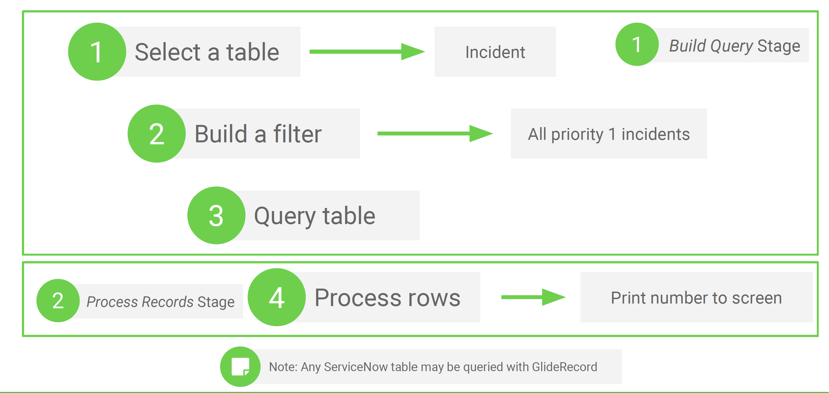
* Concept: Dot-Walking
  + 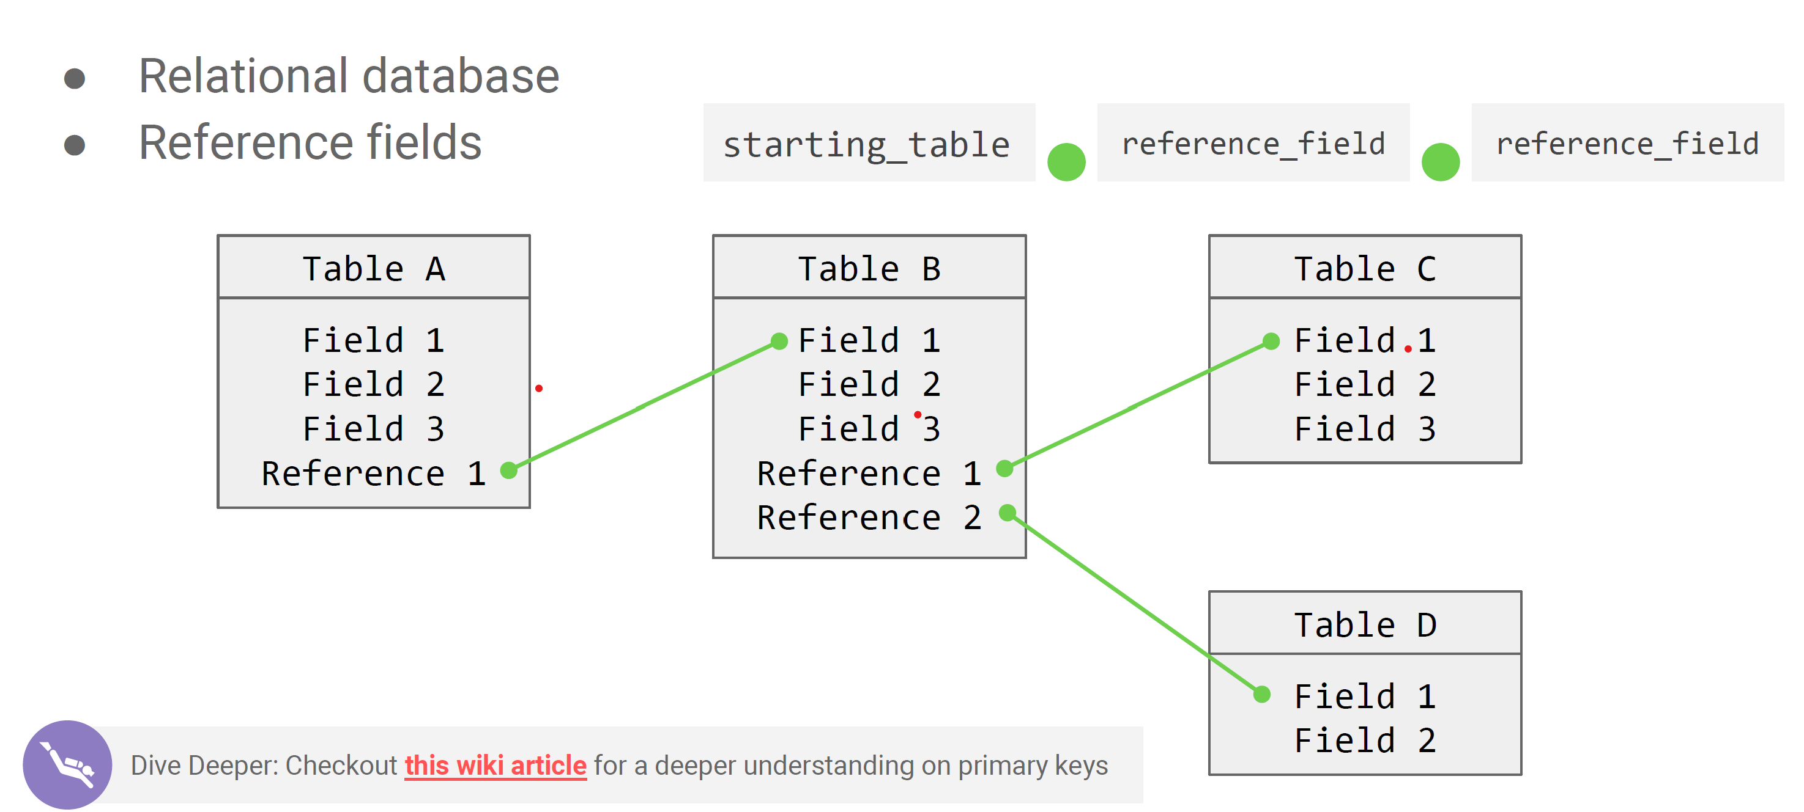
  + Example: Dot-Walking
  + For a specific incident, you would like to find the location of the caller
  + 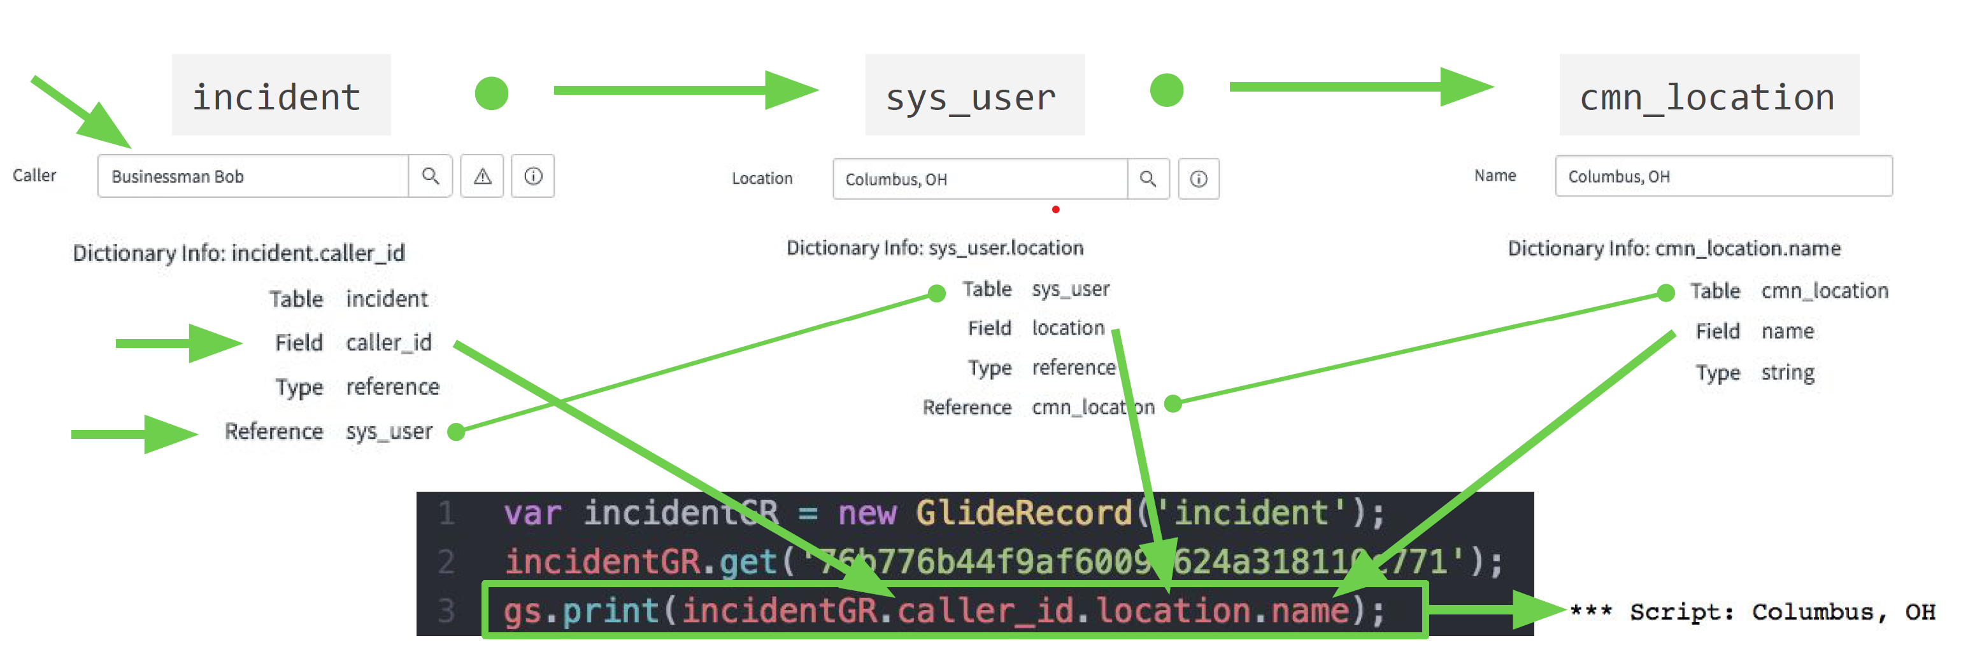
  + GlideRecord API Diagram
  + 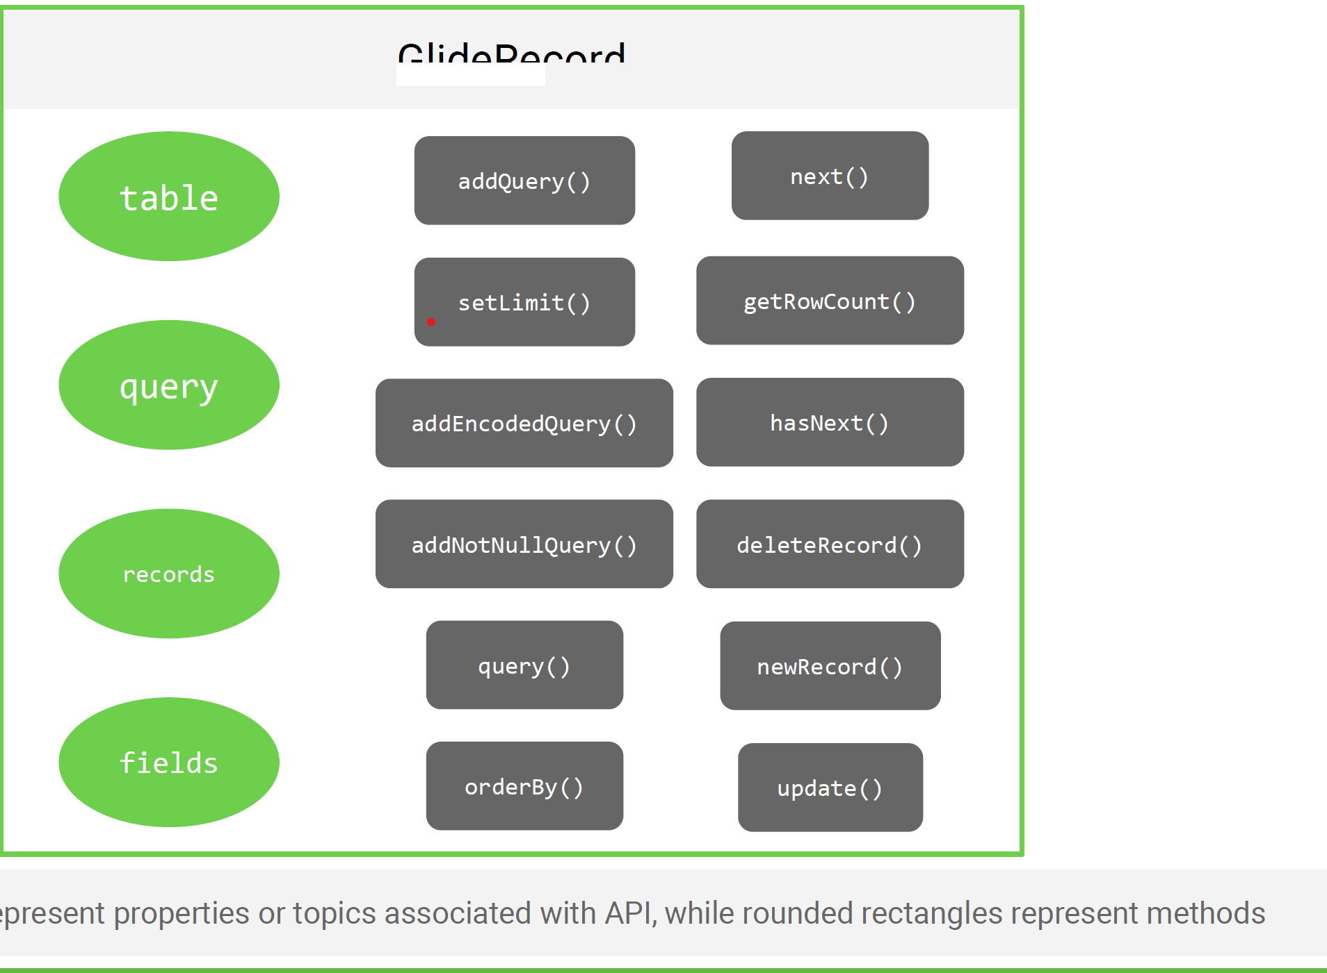
  + Common GlideRecord Methods
    - ● query()
    - ● newRecord()
    - ● insert()
    - ● update()
    - ● deleteRecord()
    - ● addQuery()
    - ● addEncodedQuery()
    - ● hasNext()
    - ● next()
    - get()
    - ● orderBy()
    - ● orderByDesc()
    - ● canCreate()
    - ● canWrite()
    - ● canRead()
    - ● canDelete()
  + GlideRecord Stage 1: Options To Build Queries
    - ● addQuery()
    - ● addOrCondition()
    - ● addNullQuery()
    - ● addNotNullQuery()
    - ● addActiveQuery()
    - ● addInactiveQuery()
    - addEncodedQuery()
    - Chain Methods
    - Add GlideRecord methods onto the current GlideRecord object
    - 1 Chain Methods
    - 
    - GlideRecord addQuery() Method

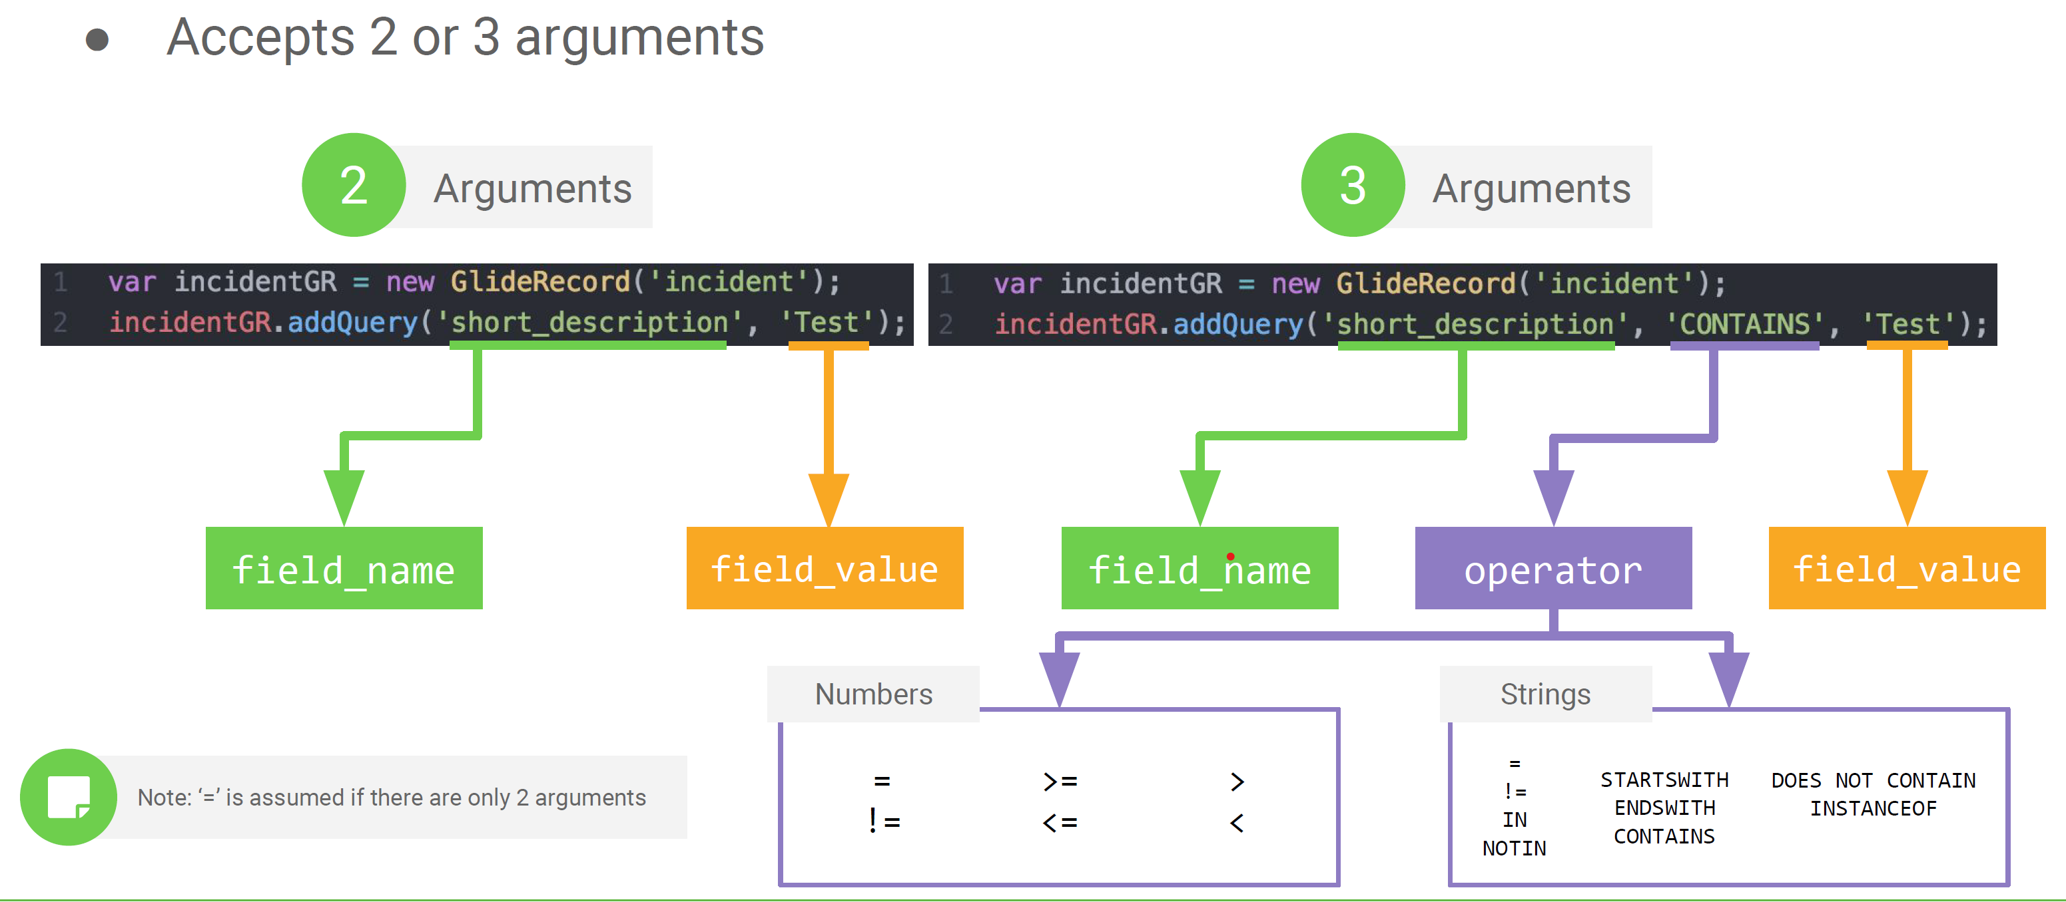

* GlideRecord Stage 1: Option 2 - Encoded Query

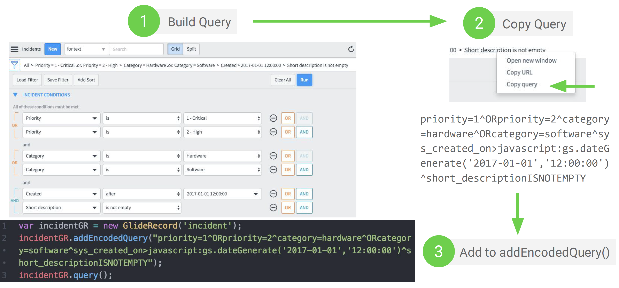

* GlideRecord get() Method
  + ● Shortcut
  + ● Only grabs 1 record
  + ● Commonly used with record sys_id
  + 
* CRUD GlideRecord Mapping
  + .insert()
  + .query()*
  + .update()
  + .deleteRecord()
  + Create
    - 1. Build GlideRecord
    - 2. query()
    - 3. newRecord()
    - 4. Set field values
    - 5. insert()
  + Read
    - 1. Build GlideRecord
    - 2. Add filter conditions (optional)
    - 3. query()
    - 4. next()
    - 5. Print or copy variables



* + Update
    - 1. Build GlideRecord
    - 2. Add filter conditions (optional)
    - 3. query()
    - 4. next()
    - 5. Set field values
    - 6. update()



* + Delete
    - 1. Build GlideRecord
    - 2. Add filter conditions (optional)
    - 3. query()
    - 4. next()
    - 5. deleteRecord()
    - 
* GlideRecordSecure
  + ● GlideRecordSecure class is inherited from GlideRecord
  + ○ Has all of the same methods
  + ○ Performs ACL checking
  + ● Used to secure Script Includes
  + ● Replaces canWrite(), canRead(), canUpdate(),
  + canDelete() GlideRecord methods
  + GlideRecord Versus GlideRecordSecure
    - 
    - 
  + GlideAggregate
    - ● Extension of GlideRecord class
    - ● Used when performing aggregate queries (count, min, max, sum, avg)
    - ○ Reports
    - ○ Calculations
    - ● Only works on number fields
    - 
  + Recap
    - Use GlideRecord when dealing with database operations
    - ● CRUD stands
    - for Create, Read, Update, Delete
    - ● GlideRecord is a server-side API
    - ● There are 2 stages to the GlideRecord API
    - ○ 1) Query building stage
    - ○ 2) Process records stage
    - ● Use the next() method to iterate over the returned records
    - ● Use the get() method to retrieve a specific record using a
    - unique field, such as the sys_id
    - ● Use GlideAggregate over GlideRecord when dealing
    - with aggregates like counts
    - ● Log records before deleting
    - ● Avoid using GlideRecord in Client Scripts
    - ● Use GlideRecordSecure where appropriate
  + System Definition => Scripts Background => can be used to execute the scripts on the servers (on the backend)
* GlideSystem
  + Overview
    - The GlideSystem API provides a number of convenient methods to get information about the system, the current logged in user, etc.
    - ● Server-side
    - ● System and user data
    - ● Referenced by gs
    - ● Doesn’t need to be invoked
    - ● Helper methods
  + Print a list of all incidents where the caller is the current user



* + Create a user greetings



* Common GlideSystem Methods
  + ● addErrorMessage()
  + ● addInfoMessage()
  + ● eventQueue()
  + ● getMessage()
  + ● getProperty()
  + ● getSession()
  + ● print()
  + ● error()
  + ● log()
  + ● debug()
  + ● info()
  + ● warn()
  + ● generateGUID()
  + ● getUser()
  + ● hasRole()
  + ● isLoggedIn()
  + ● isMobile()
  + ● nil()
  + ● setRedirect()
  + ● setProperty()
* 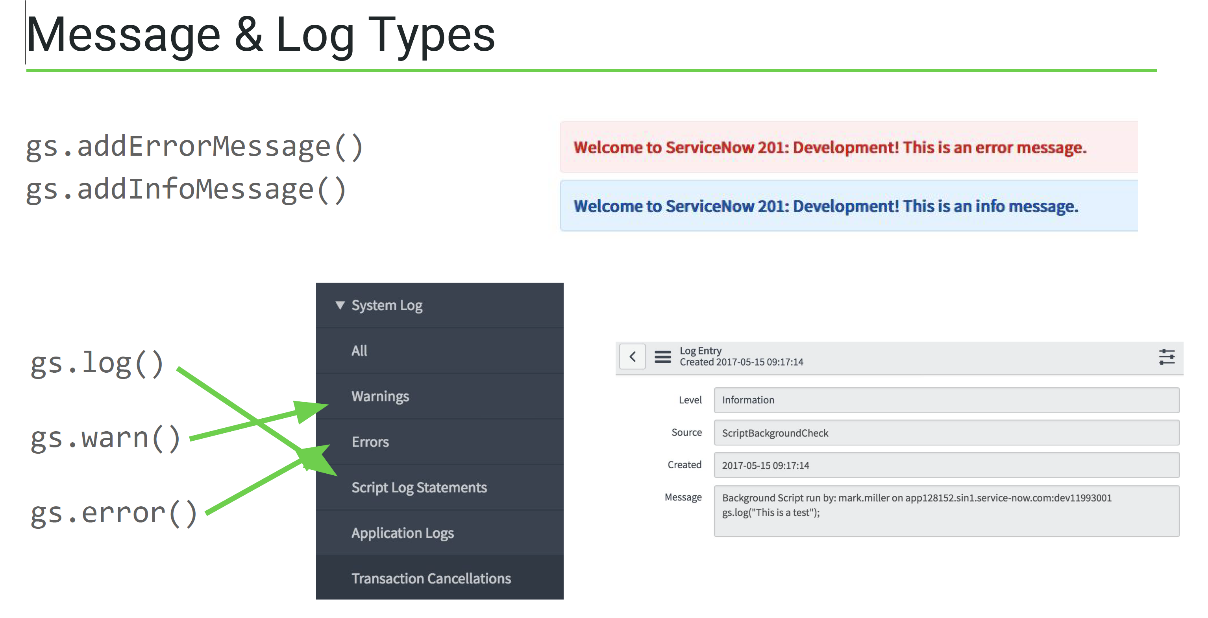
* GlideSystem getMessage() Method (used for translation based on the mapping inputs defined for the login user in te sys_ui_message table)
  + ● Provides a way to translate text easily
  + ● Uses the sys_ui_message table
  + ● First argument is the string of the message
  + ● System uses current user language as another parameter
  + 
* GlideSystem getProperty() Method (this is similar to DSS)
  + ● Get a system property
  + ● Best practice instead of hard-coding
* GlideSystem nil() Method (used for comparing the null values of properties)
  + ● Every field in a GlideRecord is an object
  + ● Empty string comparison doesn’t always work
  + 
  + 
* Concept: Events
  + User Events
    - ● Mouse click
    - ● Mouse movement
    - ● Key press
  + System Events
    - ● Time
    - ● Database operation
    - ● Network activity
* Events in ServiceNow
  + ● Can be triggered by:
  + ○ CRUD operations on tables (Business Rules)
  + ○ Workflow activities
  + ○ Scripts (Scheduled Jobs, Web Services, etc.)
  + ● Must be registered
  + ● Event components:
  + ○ Registry
  + ○ Event action (Script Action, Notification)
  + ○ Event log
* Event Component: Registry
  + 
* Event Component: Event Action
  + 
  + 
* Event Component: Event Log
* Process: Event Queue
  + 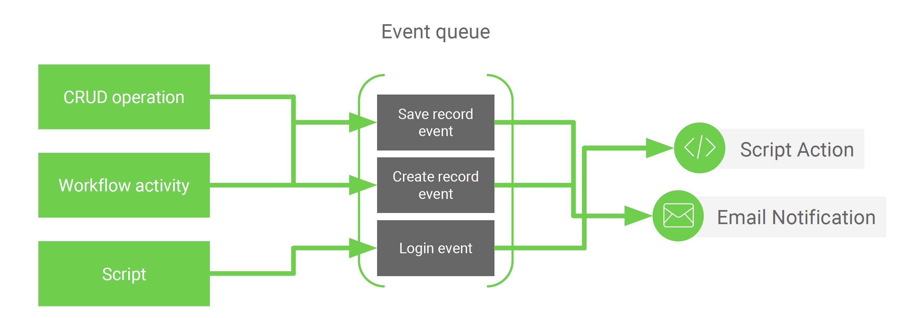
    - Script Actions Scripts invoked via registered events
      * ● Server side
      * ● Scope
      * ○ current
      * ○ event
      * ■ parm1
      * ■ parm2



* GlideSystem eventQueue() Method
  + ● Add events to the event queue
  + ● Parameters
  + ○ Event name
  + ○ GlideRecord object
  + ○ Optional parameter
  + ○ Optional parameter
  + eventQueue(‘event.name’, current, parm1, parm2)

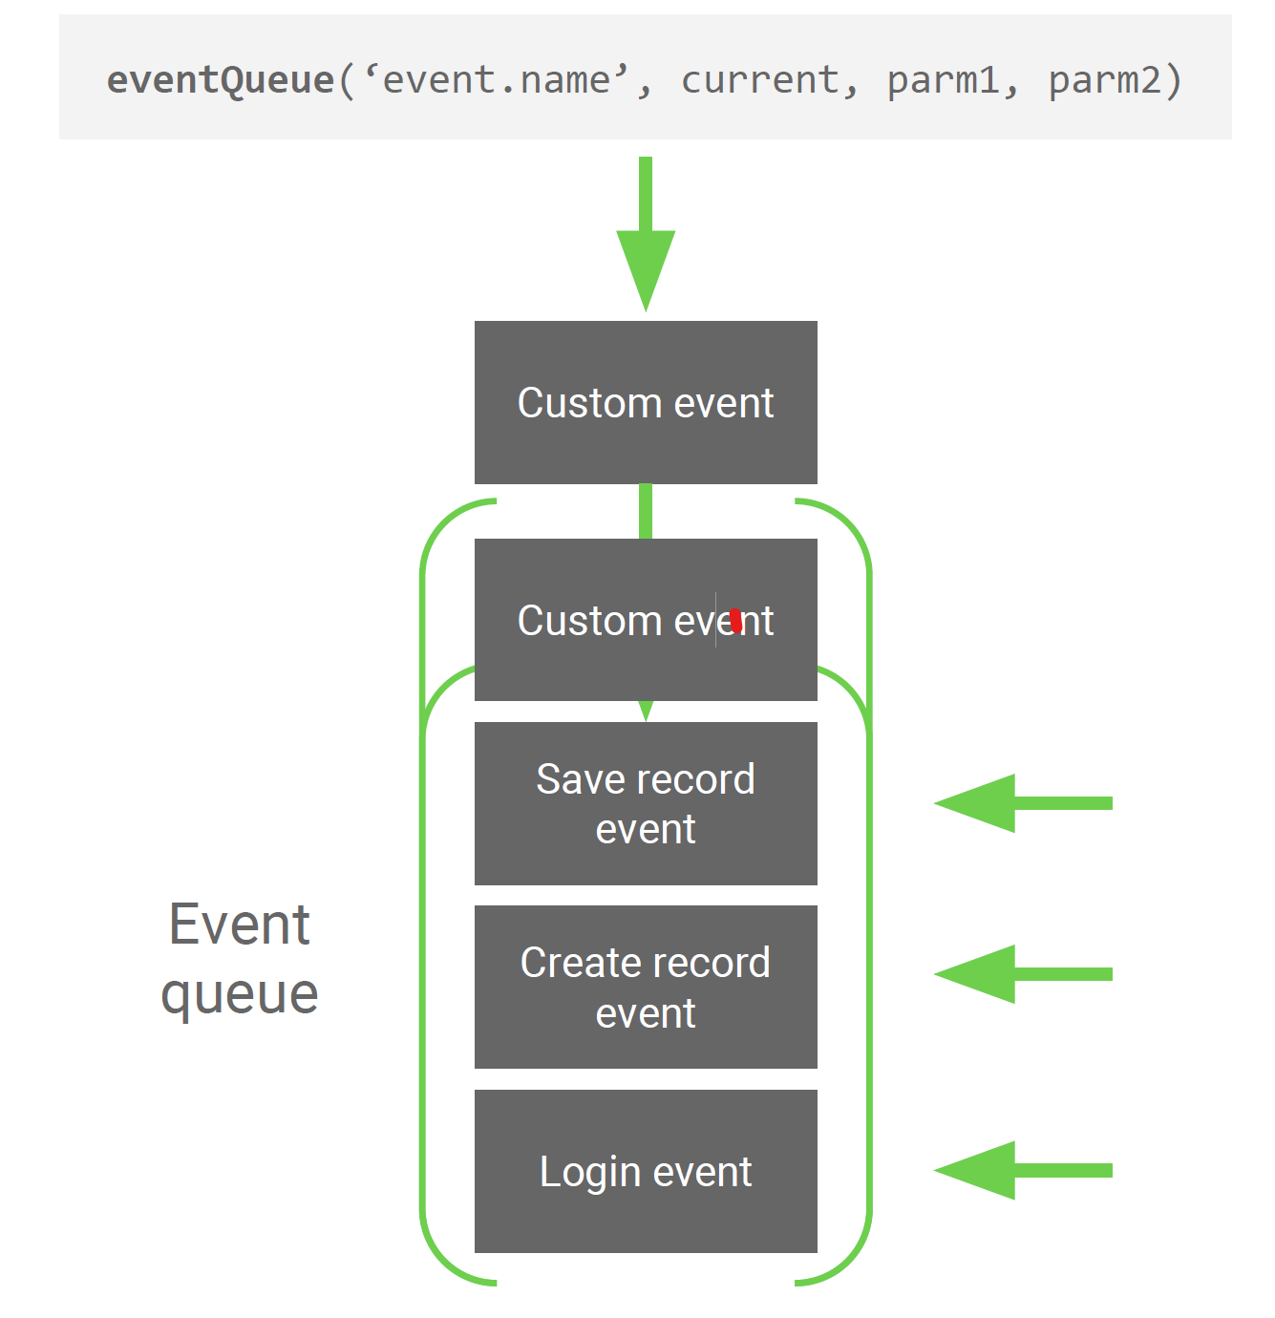

* Demo: Log Hello world! Using Events

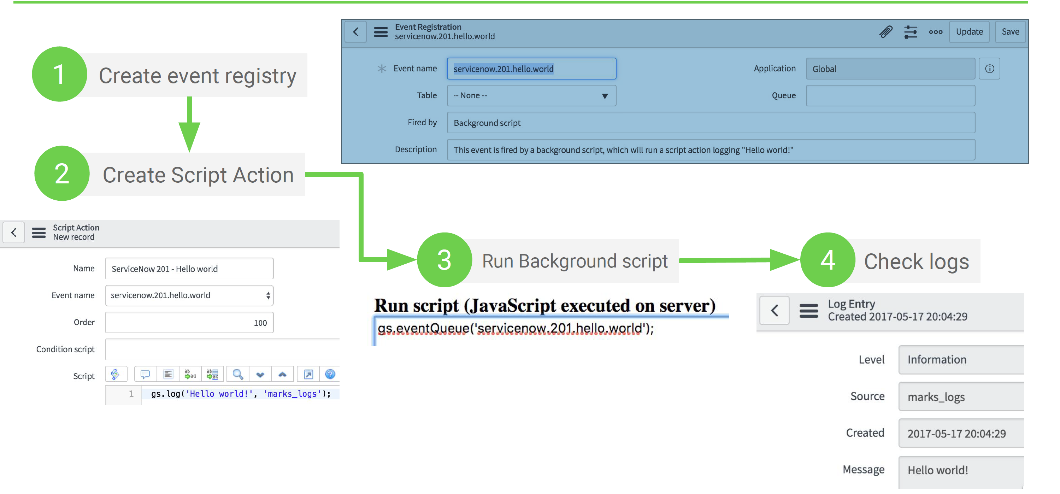

* GlideForm
  + The GlideForm API provides methods to customize forms… The global object g_form is used to access GlideForm methods. GlideForm methods are only used on the client… These methods are used to make custom changes to the form view of records.
  + ● Client-side
  + ● Changes to form & fields
  + ● Referenced by g_form
  + Set short description to mandatory when priority changes.



* + Client-Side Environment
    - ● In browser
    - ● Access to client-side APIs
    - ○ Most are accessible via global scope
    - ● Ctrl + Shift + j
    - ● Debug to browser console
    - ○ console.log()
    - ○ console.dir()
  + GlideForm API Overview

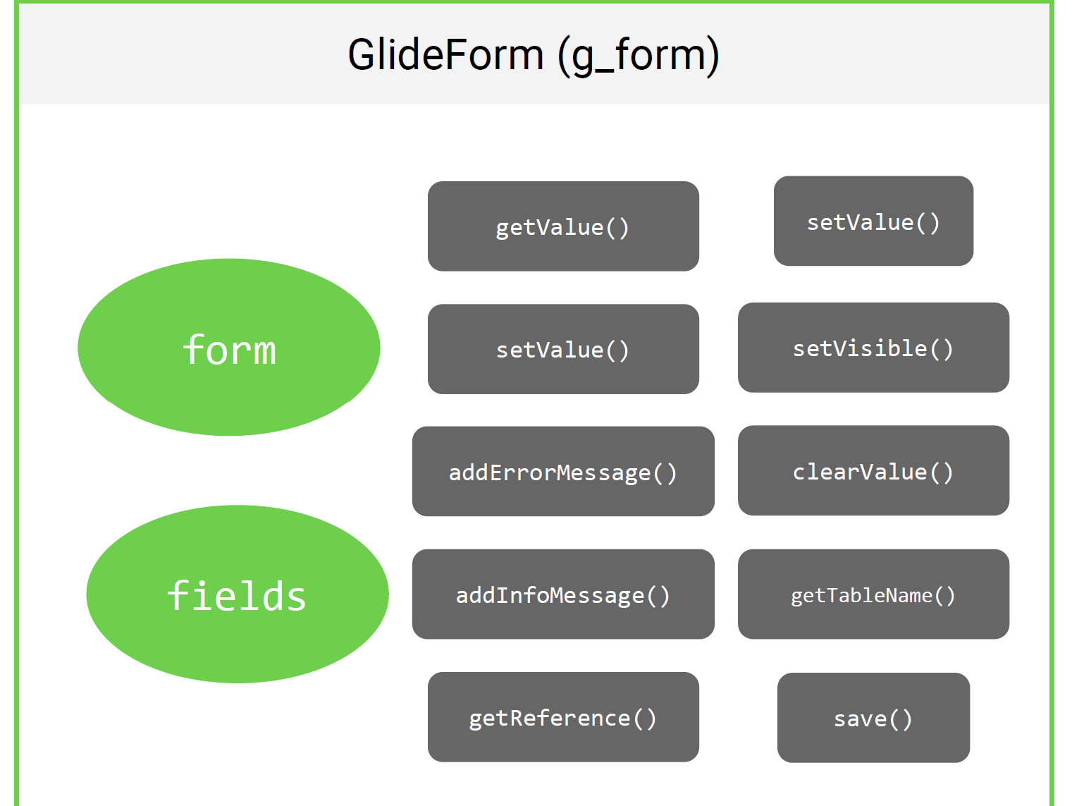

* + Common GlideForm Methods
    - addErrorMessage()
    - ● addInfoMessage()
    - ● addOption()
    - ● clearOptions()
    - ● clearValue()
    - ● disableAttachments()
    - ● enableAttachments()
    - ● getLabelOf()
    - ● getOption()
    - ● getReference()
    - ● hideRelatedLists()
    - ● isMandatory()
    - ● removeOption()
    - ● setDisabled()
    - ● setReadOnly()
    - ● setVisible()
    - ● setValue()
  + GlideForm getValue() & setValue() Methods
    - ● Getter and setter methods for form fields
    - ● getValue() accepts the field name as an argument
    - ● setValue() accepts the field name and new value as arguments
  + GlideForm getReference() Method
    - ● Form only loads fields associated with record on form
    - ● Use getReference() to retrieve referenced field values
    - ● Leverages JavaScript callbacks



* + GlideForm getReference() Method
    - ● Form only loads fields associated with record on form
    - ● Use getReference() to retrieve referenced field values
    - ● Leverages JavaScript callbacks



* + GlideUser
    - The GlideUser API provides access to information about the current user and current user roles. Using the GlideUser API avoids the need to use the slower GlideRecord queries to get user information.
    - ● Client-side
    - ● User information
    - ● Referenced by g_user
    - ● Relatively small & simple
    - API
  + Check if the current user has the ITIL role



* + GlideUser Methods & Properties
    - ● firstName
    - ● lastName
    - ● userID
    - ● userName
    - ● getClientData()
    - ● getFullName()
    - ● hasRole()
    - ● hasRoleExactly()
    - ● hasRoleFromList()
    - ● hasRoles()
  + GlideUser hasRoleExactly() Method
    - ● Takes the name of a role as its argument
    - ● Returns true only if user has the specified
    - role, even if current user is admin



* + GlideUser Properties
    - ● Object properties
    - ● Don’t need getter methods



* GlideAjax Introduction
  + ● Client-side
  + ● Used to call server-side Script Includes
  + ● Similar to jQuery’s ajax method
  + ● Asynchronous JavaScript and XML
  + ● Popularized by Google in Google Maps and Gmail
  + ● Way to make client-side requests to server-side without requiring a “page reload”
  + ● Uses browser’s XMLHttpRequest API

























* Revisiting Script Includes
  + ● Run on the server-side
  + ● Contain reusable snippets of code, making them modular
  + ● Only executed when invoked from another source
  + ○ Client-side using GlideAjax
  + ○ Server-side using the new JavaScript operator
  + ● May extend other JavaScript classes
  + ● When used for GlideAjax
  + ○ Must have Client callable set to true
  + ○ Extends the AbstractAjaxProcessor class
  + ○ Typically queries a table and returns record(s) to client-side as JSON
  + ○ Has access to any variable from client-side that starts with sysparm_
  + ○ Uses sysparm_name to invoke method in Script Include
* Extending AbstractAjaxProcessor
  + ● AbstractAjaxProcessor is an out-of-the-box Script Include
  + ● Provides helper methods
  + ● Client callable checkbox automatically generates required JavaScript





* The GlideAjax Script Include
  + 1. Method passed in sysparm_name gets invoked
  + 2. Server-side scripts are ran
  + 3. return statement ends server-side script execution
  + 4. Response is packaged up as XML and sent to client

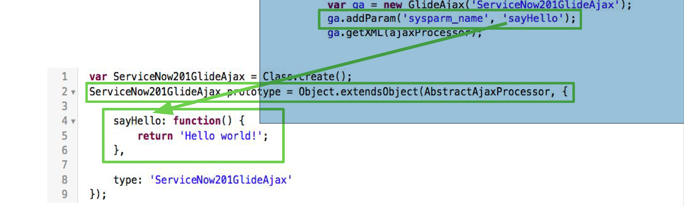

* + ● XML is returned to the client-side from server-side (even if JSON)
  + ● Use the following to retrieve answer
  + ○ response.responseXML.documentElement.getAttribute(‘answer’)

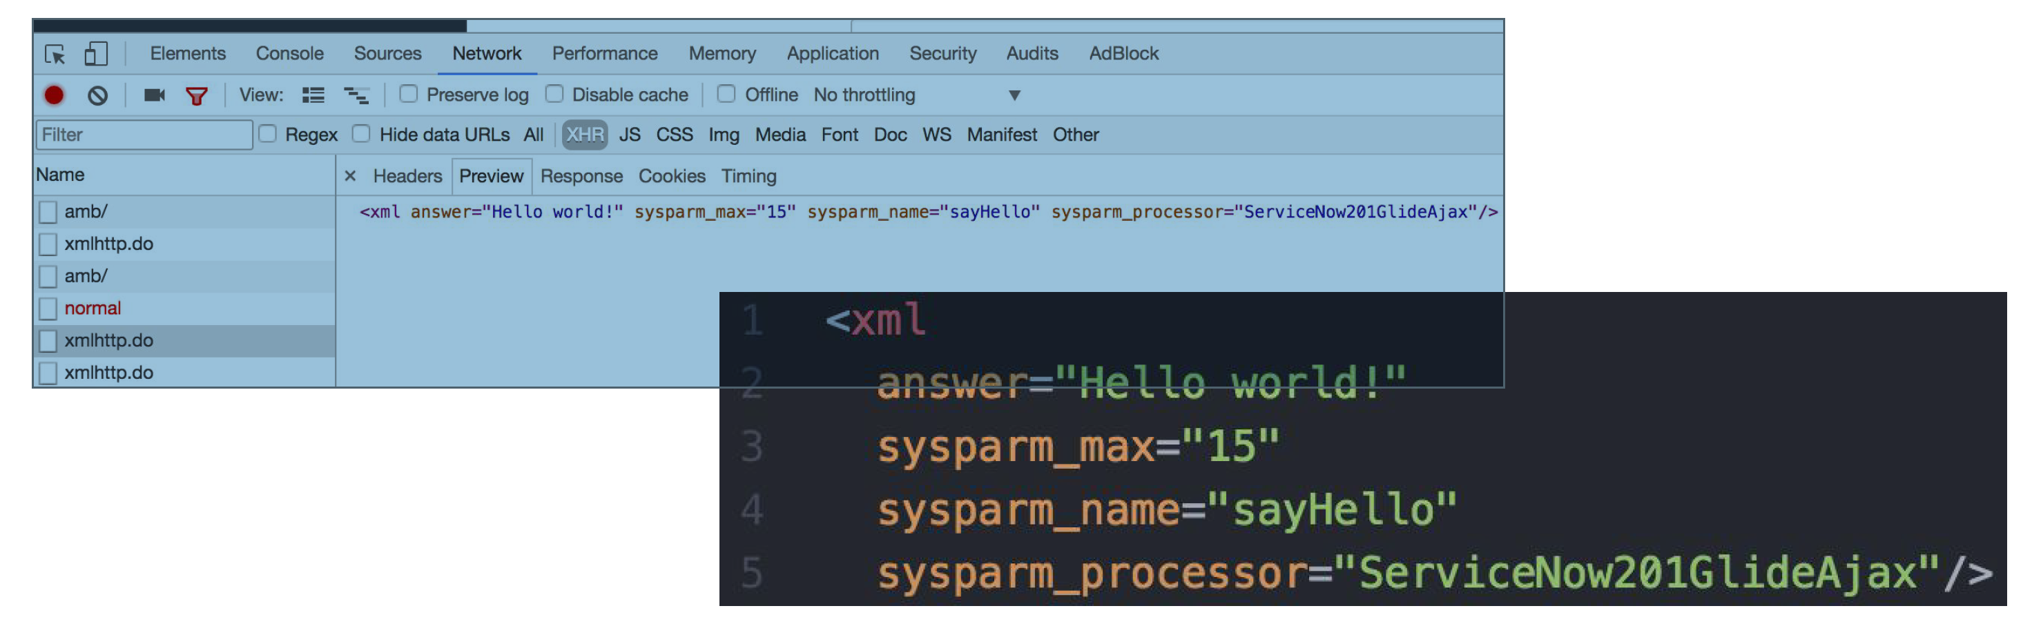

* + The JavaScript Callback
    - ● A callback is a function that is passed as an argument, which is
    - then executed at a later time
    - ● Once the client receives the response from the server, the callback
    - is invoked



* + JSON Or XML?
    - ● JavaScript Object Notation
    - ● Very easy & fast to parse
    - ● Uses collections of key/value pairs
    - ● Supports arrays
    - ● Extensible Markup Language
    - ● Uses nodes & node attributes
    - ● Can be a pain to parse
  + GlideAjax getXMLAnswer() Method
    - ● Shortcut to ○ getXML()
    - ○ response.responseXML.documentElement.getAttribute(‘answer’)



* + GlideAjax API Overview
    - addParam()
    - getXML()
    - getXMLAnswer()
* GlideDateTime API
  + ● Used for
  + ○ Date/time operations
  + ○ Formatting date/time
  + ○ Converting between date/time formats
  + ● Server-side API



* Common GlideDateTime Methods
  + ● add()
  + ● addDaysUTC()
  + ● addMonthsUTC()
  + ● addSeconds()
  + ● addWeeksUTC()
  + ● addYearsUTC()
  + ● after()
  + ● before()
  + ● compareTo()
  + ● equals()
  + ● getDate()
  + ● getDayOfMonthUTC()
  + ● getLocalTime()
  + ● getMonthUTC()
  + ● getTime()
  + ● getWeekOfYearUTC()
  + ● getYearUTC()
  + ● isValid()
  + ● onOrAfter()
  + ● onOrBefore()
  + ● subtract()
* GlideElement API
  + ● Used for:
  + ○ Accessing GlideRecord fields
  + ○ Manipulating GlideRecord fields
  + ● Server-side API
  + Direct access versus toString() versus getDisplayValue()
  + GlideElement getHTMLValue() Method



* + GlideElement getJournalEntry() Method
  + 
* XMLDocument2 API
  + ● Used for:
  + ○ Working with XML documents & nodes
  + ● Server-side API
* More Documented APIs
  + ● GlideModal
  + ● Workflow
  + ● GlideSysAttachment
  + ● RESTMessageV2
  + ● RESTResponseV2
  + ● SOAPMessageV2
  + ● SOAPResponseV2
  + ● GlideDuration
* Undocumented APIs
  + ● Script Includes or inaccessible server scripts
  + ● Common undocumented APIs
  + ○ JSUtils*
  + ○ Workflow
  + ○ DiscoveryCMDBUtil
  + ○ AssetandCI
  + ○ CMDBItem
  + ○ SNC
  + ○ GlideStringUtil
  + ○ Cart
  + ○ SPCart
  + ○ Hundreds more...
* Best Practices: General Scripting
  + ● Add a short description to scripts when available
  + ● Use condition statements if condition field is
  + available depending on scripting location
  + ● Comment your code! (source)
  + ● Follow a convention - especially for debugging
  + ● Wrap code in functions to prevent polluting the
  + global namespace (source)
  + Do not use hardcoded values (source)
  + ● Use descriptive variables and function names (source)
  + ● Verify a value exists before using it (source)
  + ● Let the database do the work (source)
  + ● Use GlideAggregate over GlideRecord when dealing
  + with aggregates like counts
  + ● Log records before deleting
  + ● Use GlideRecordSecure where appropriate
  + ● Use Script Includes over global Business Rules
* Best Practices: Client-Side
  + ● Make as few calls as possible
  + ● Do not make synchronous calls
  + ○ GlideRecord on client-side
  + ○ g_form.getReference w/o callback
  + ● Use GlideAjax when passing data between server-side
  + & client-side
  + ○ Use JSON when passing data from server-side to client-side
  + ● Debug using console.log
  + ● Avoid direct DOM manipulation
  + ● Use UI Policies over Client Scripts when available

ServiceNow

○ Coding Best Practices

○ Client Script Best Practices

○ Business Rule Best Practices

○ Commenting Best Practices

○ Update Set Best Practices

● Other

○ servicenowguru.com

* ○ servicenowelite.com

<https://servicenowguru.com/scripting/gliderecord-query-cheat-sheet/>

**Processors:**

Welcome back to another tutorial . In this tutorial we will be looking into a rarely known aspect in servicenow . Today we will be lloking into ServiceNow Processors. We will understand 1. What is ServiceNow Processors 2. Usage of ServiceNow processors 3. Demo Example on ServiceNow Processors Lets first understand what is ServiceNow Processors ServiceNow PRocessors : Processors provide a customizable URL endpoint that can execute arbitrary server-side JavaScript code and produce output such as TEXT, JSON, or HTML. Creating custom processors is deprecated. When to Create Processors Do not create custom processors. This feature is deprecated. Please use the REST APIs instead of creating custom processors. The remaining information is left for existing processors only. Processors in ServiceNow are (were) actually extremely useful things, though they’re surprisingly not very well-known. They give you a URL you can hit (like my_processor.do) and allow you to run a server-side script, then redirect the user to some other page. Processors are quite useful for situations like generating a record and then redirecting the user to that record just by navigating to one URL, or - by adding some URL parameters (like my_processor.do?some_param=some_value) automating some simple or complex processes with nothing more than a single click of a URL! You can generate that URL dynamically and present it in the UI somewhere (for example, by using gs.addInfoMessage()), or link to the processor in an email. You could even use something like my “Set Catalog Variables from URL Parameters” tool in conjunction with this functionality to dynamically populate and submit RITMs from a single click of a link in a Knowledge Article! ServiceNow_Second_Edition_Kindle.png Some pre-existing useful processors are: System cache flush (cache.do) Attachment processor for constructing and viewing attachments (sys_attachment.do) Content search (content_search.do) Customer service chat (CustomerServiceChat.do) Export Wizard (export_wizard.do) While it’s possible to modify the ACLs on the Processor table to allow you to create them again (for now), that may not be the best idea for long-term support. So, if we don’t use a processor, how can we accomplish this functionality in our app? The answer is Scripted REST APIs (SRAPIs) plus a little bit of HTTP header magic! In this article, we’re going to show you how to accomplish (mostly) the same functionality as a processor using an SRAPI, and provide some code you can use to get your pseudo-processor SRAPI up and running within minutes! We’ll also provide some best-practice advice for how to use SRAPIs in this way, and outline some specific use-cases for this sort of thing. There are a few very important things to note about this approach, which I’ll list below. Please do not attempt this in your instance without carefully reading the below points! The SRAPI method should be GET. Requires authentication should be set to false. Unless you want unauthenticated users to be able to trigger your SRAPI script to run as often as they want (very risky), you must be sure to include gs.isLoggedIn() as a condition for your script running, before it does anything important! See my comments and conditional return on lines 14 - 23 in the code above, which prevent unauthenticated users from using this pseudo-processor. I have not yet found a better way of doing this, which is a little disappointing since Processors just handled it for you (including the redirect after the login). If I come up with anything more friendly, I’ll update this article. If you have any ideas, please reply in the comments and you’ll be credited for the suggestion if it works! The redirect URL (the second argument to the redirect() function) must be a full URL, including http(s) or another resource/protocol identifier. Please follow subscribe to my channel Technomonk and press the bell icon to get the latest update on my new videos. Till then stay happy and safe. Have a nice day. Regards, Amit Gujarathi